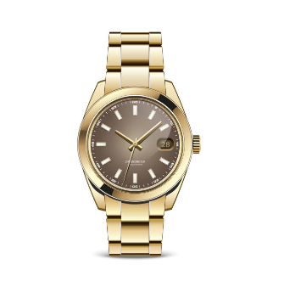

**Product Name:**

Gold Wristwatch

**Description:**

This luxurious gold wristwatch features a stylish brown dial with gold accents. The round case and metal bracelet are crafted for a refined look, making it an ideal accessory for elegant occasions. The watch includes gold hour markers, gold hands, and a convenient date display at the 3 o’clock position.

**Specifications:**

* **Material:** Gold metal strap and case
* **Dial Color:** Brown
* **Hour Markers:** Gold
* **Hands:** Gold
* **Date Display:** Positioned at 3 o’clock
* **Movement:** Quartz
* **Water Resistance:** Not specified
* **Case Diameter:** Not specified
* **Strap Type:** Metal bracelet
* **Closure:** Fold-over clasp

**Price:**

74,999